**Printable Writing Form:**

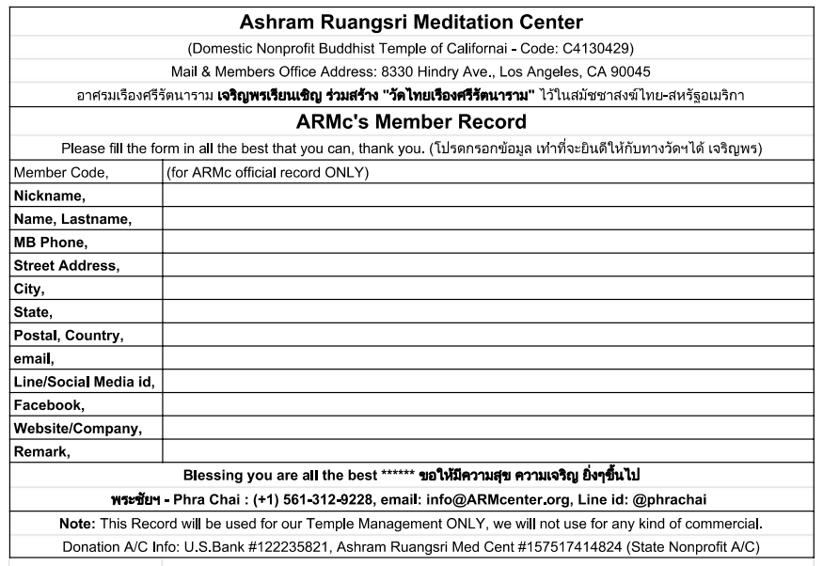

**Typing TXT Form:**

|  |  |
| --- | --- |
| **Nickname,** |  |
| **Name, Last Name,** |  |
| **MB Phone,** |  |
| **Street Address** |  |
| **City,** |  |
| **State,** |  |
| **Postal, Country,** |  |
| **email,** |  |
| **Line/Social Media id,** |  |
| **Facebook,** |  |
| **Website / Company,** |  |
| **Remark,** |  |

**Sample:**

ARMc's Member Record, Form Filling:

|  |  |
| --- | --- |
| **Nickname,** | Phra Chai |
| **Name, Last Name,** | Phra Chaianunt Jayabhinunto |
| **MB Phone,** | 561 312 9228 |
| **Street Address** | 8330 Hindry Ave |
| **City,** | Los Angeles |
| **State,** | CA |
| **Postal, Country,** | 90045 |
| **email,** | chaianunt@gmail.com |
| **Line/Social Media id,** | Line@id: @phrachai, Line id: phrachai, IG: phrachai, Twitter: DhammasalaNET |
| **Facebook,** | Phrachai Jayabhinunto |
| **Website / Company,** | www.Phrachai.net |
| **Remark,** | www.ARMcenter.org |

ขอความสุข ความเจริญในธรรม จงมีแด่ท่านสืบไป  
ขออำนวยพร ขอเจริญพร  
นิพพานะ ปัจจะโย โหตุ  
เอวัง โหตุ